Name: B C Yugesh Reg no: 192424282
Course Code: DSA0604

- Bar Chart
employee <- read.csv("Employee.csv")
edu <- table(employee$Education)
barplot(edu,
col=c("skyblue","orange","green"),
main="Employees by Education",
xlab="Education",
ylab="Number of Employees")
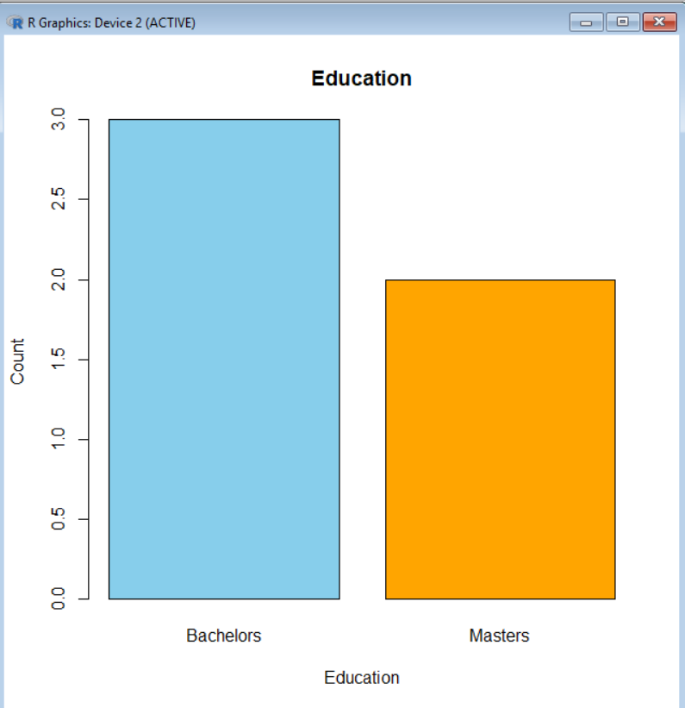

- Pie Chart
employee <- read.csv("Employee.csv")
gen <- table(employee$Gender)
pie(gen,
col=c("pink","lightblue"),
main="Employees by Gender")
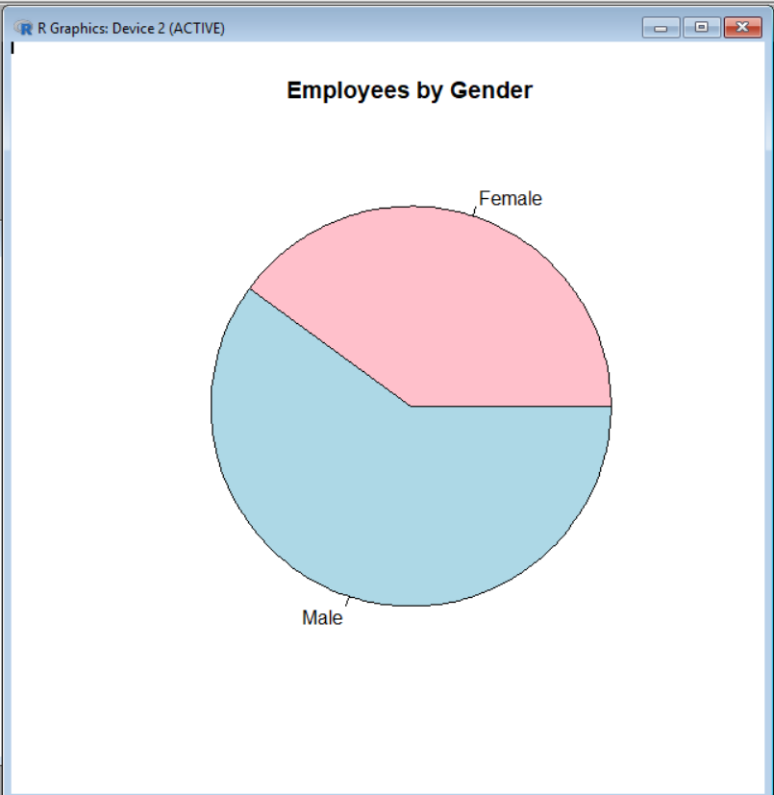

- Line Chart
employee <- data.frame(
JoiningYear = c(2012,2013,2014,2015,2016,2017,2018,
2016,2017,2015,2014,2013,2012,2018,2017)
)
join <- table(employee$JoiningYear)
plot(join,
type="o",
col="blue",
lwd=2,
pch=16,
main="Employees by Joining Year",
xlab="Joining Year",
ylab="Number of Employees")
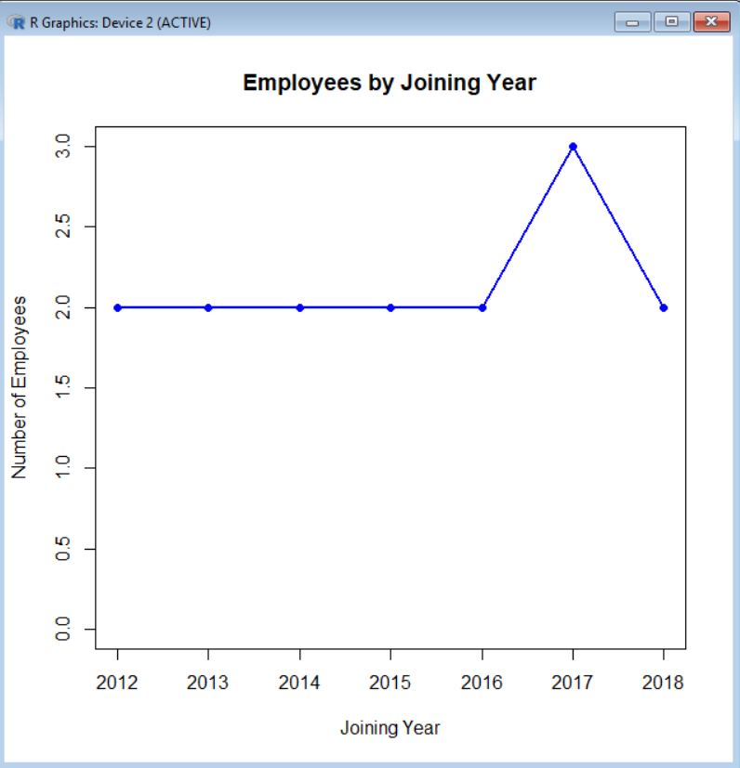

- Histogram
employee <- data.frame(
Age=c(22,24,25,26,27,28,29,30,31,32,
24,25,26,28,30)
)
hist(employee$Age,
col="orange",
border="black",
main="Age Distribution",
xlab="Age")
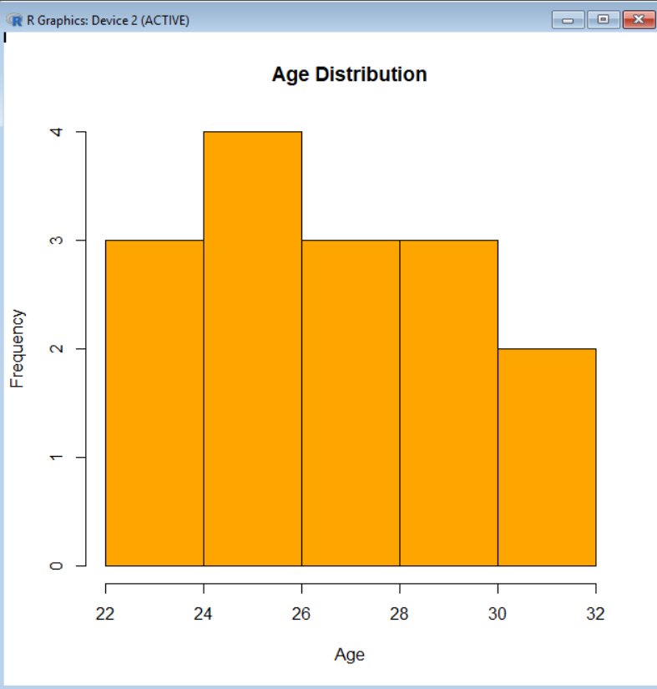

- Scatter Plot
employee <- data.frame(
Age=c(22,24,26,28,30,32,34,36),
Experience=c(1,2,3,4,5,6,7,8)
)
plot(employee$Age,
employee$Experience,
col="red",
pch=19,
main="Age vs Experience",
xlab="Age",
ylab="Experience")
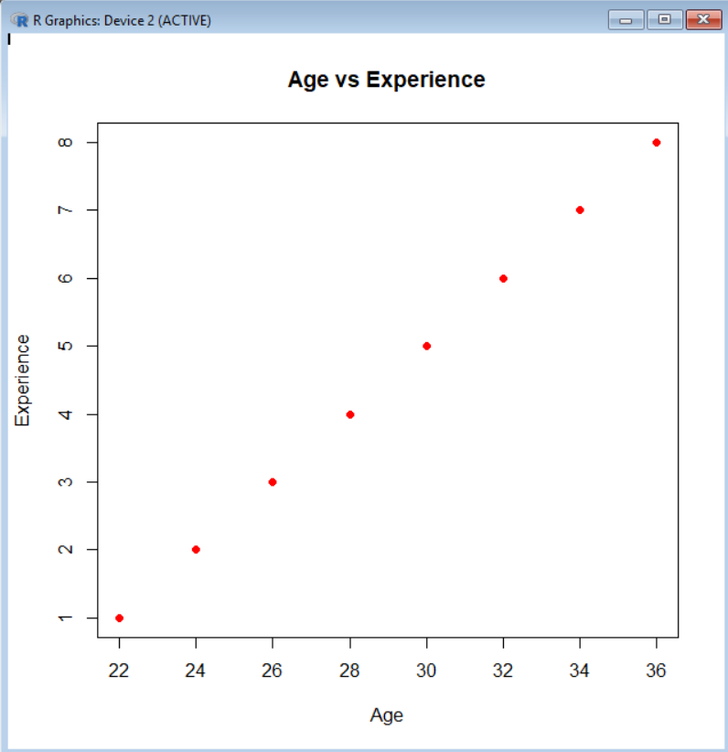

- Box Plot
employee <- data.frame(
Age=c(22,24,25,26,27,28,29,30,31,32)
)
boxplot(employee$Age,
col="green",
main="Age Box Plot")
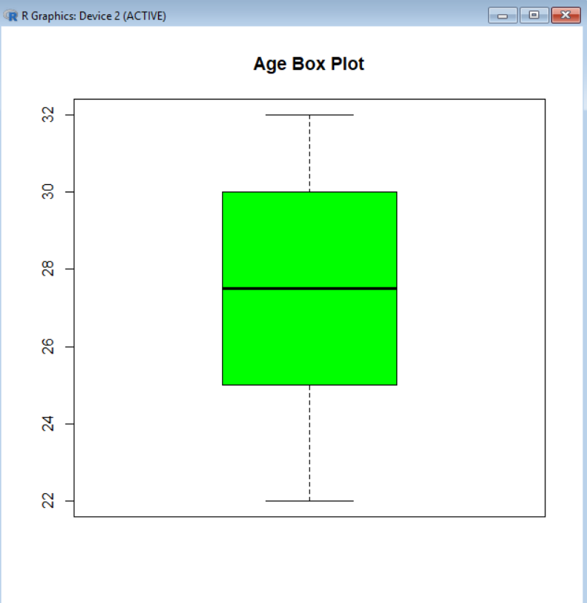

- Dot Chart
employee <- data.frame(
City=c("Bangalore","Pune","Delhi","Pune",
"Delhi","Bangalore","Pune",
"Delhi","Bangalore","Pune")
)
dotchart(table(employee$City),
main="Employees by City")
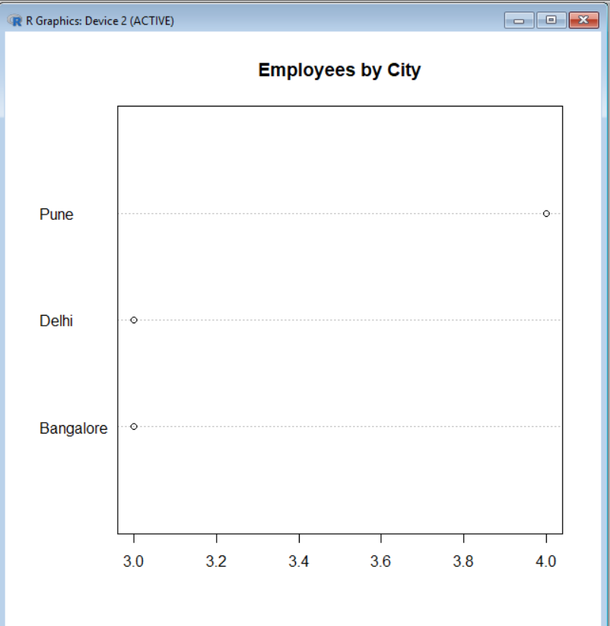

- Density Plot
employee <- data.frame(
Age=c(22,24,25,26,27,28,29,30,31,32)
)
plot(density(employee$Age),
col="blue",
lwd=2,
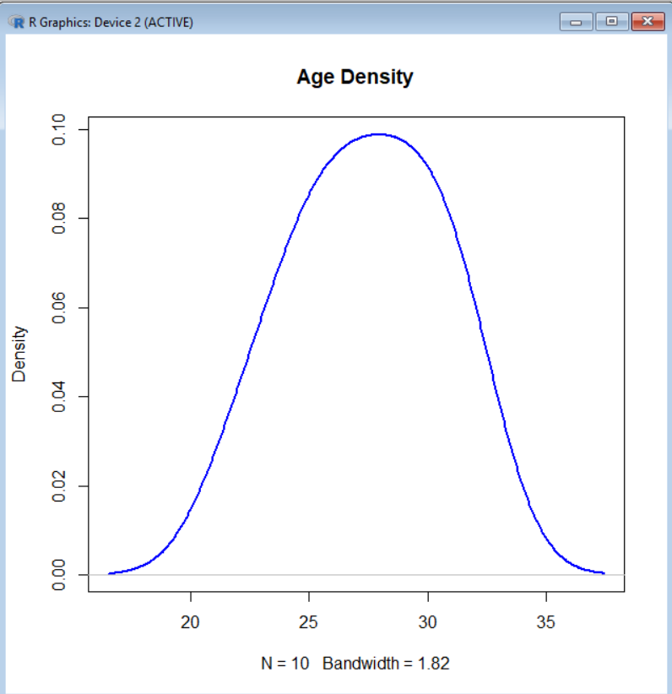
main="Age Density")

- Area Chart
employee <- data.frame(
JoiningYear = c(2012,2013,2014,2015,2016,2017,2018,
2016,2015,2014,2017,2018,2013,2012,2016)
)
join <- table(employee$JoiningYear)
plot(join,
type = "l",
lwd = 2,
col = "blue",
main = "Employees by Joining Year",
xlab = "Joining Year",
ylab = "Number of Employees")
polygon(c(1:length(join), length(join), 1),
c(join, 0, 0),
col = "lightblue",
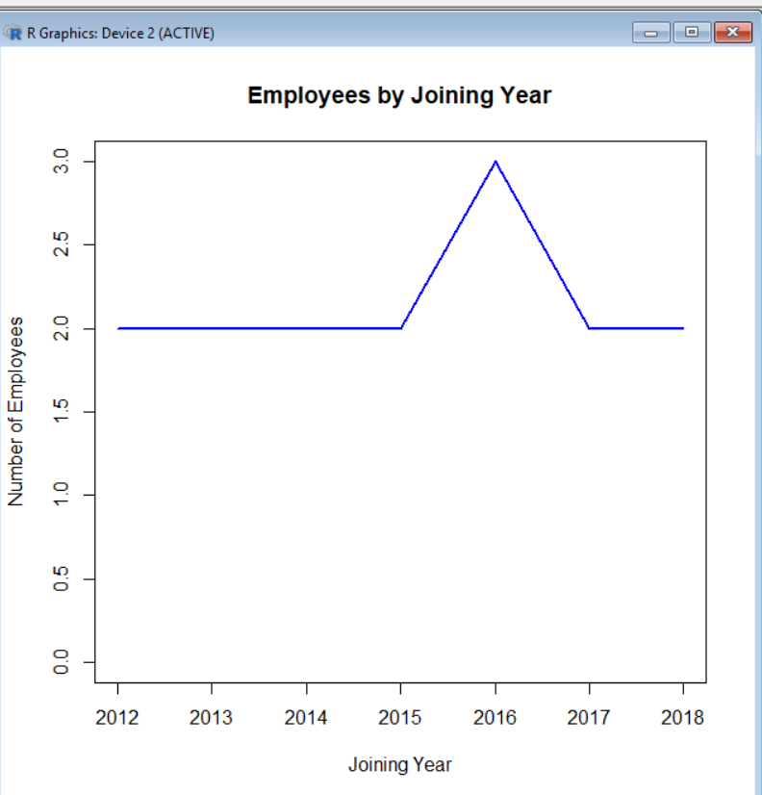
border = "blue")

10. Heat Map
employee <- data.frame(
Age = c(22,24,26,28,30,32,34,36),
PaymentTier = c(1,2,2,3,3,2,1,3),
Experience = c(1,2,3,4,5,6,7,8)
)
data <- cor(employee)
heatmap(data,
col = heat.colors(10),
scale = "none",
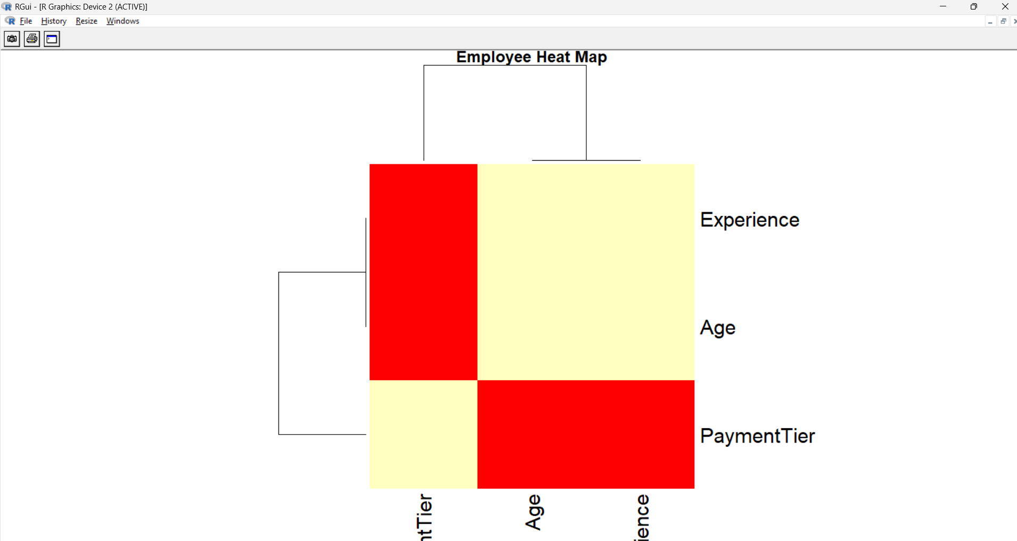
main = "Employee Heat Map")

11.Stem Plot
employee <- data.frame(
Age=c(22,24,25,26,27,28,29,30,31,32)
)
stem(employee$Age)
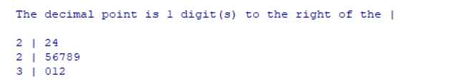

12. Bubble Chart
employee <- data.frame(
Age = c(22,24,26,28,30,32,34,36),
Experience = c(1,2,3,4,5,6,7,8),
PaymentTier = c(1,2,2,3,3,2,1,3)
)
plot(employee$Age,
employee$Experience
cex = employee$PaymentTier + 1,
pch = 21,
bg = "skyblue",
col = "blue",
xlab = "Age",
ylab = "Experience",
main = "Bubble Chart")
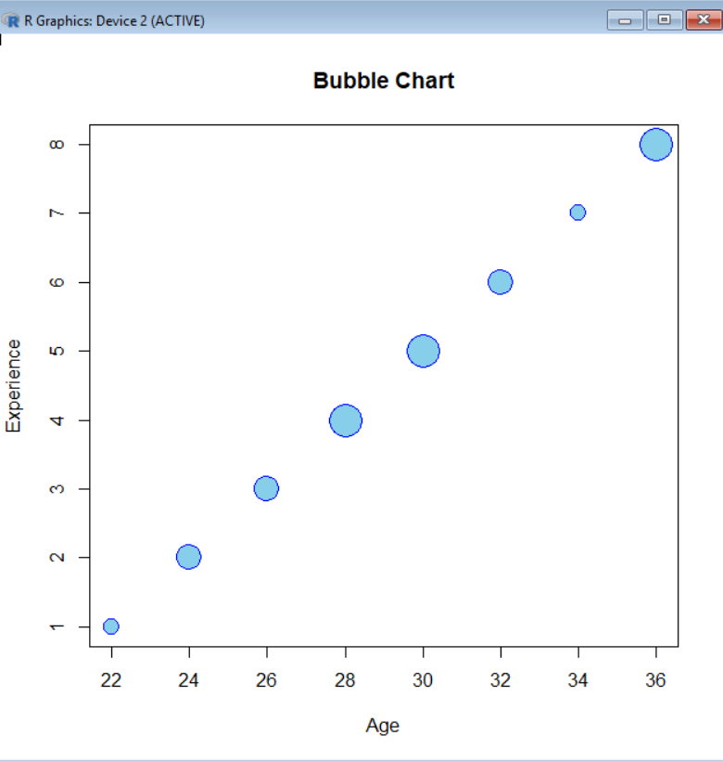

13. Density chart
employee <- data.frame(
Age = c(22,24,25,26,27,28,29,30,31,32,
24,25,26,28,30,32,34,36,27,29)
)

# Density Plot
plot(density(employee$Age),
main = "Density Plot of Employee Age",
xlab = "Age",
ylab = "Density",
col = "blue",
lwd = 2)

polygon(density(employee$Age),
col = "lightblue",
border = "blue")
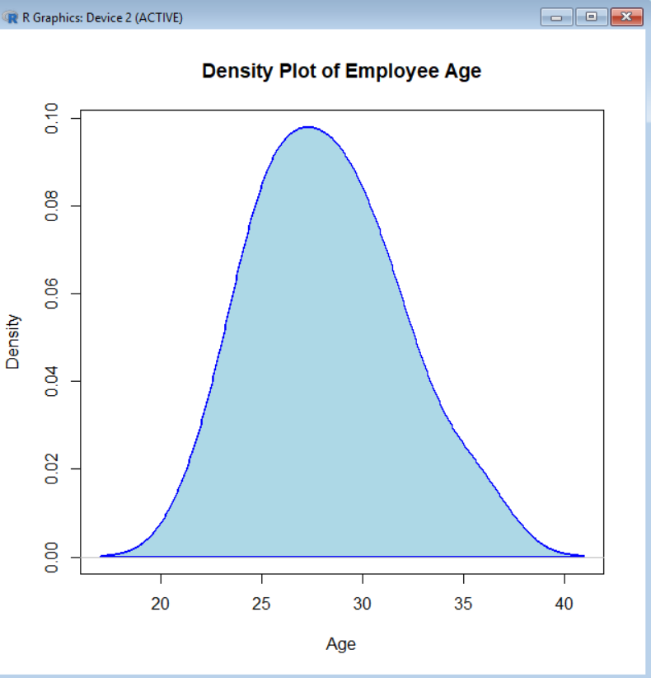

14. Grouped Bar Char
employee <- data.frame(
Education = c("Bachelors","Bachelors","Masters","Masters",
"PHD","PHD","Bachelors","Masters"),
Gender = c("Male","Female","Male","Female",
"Male","Female","Male","Female")
)
group <- table(employee$Education, employee$Gender)
barplot(group,
beside = TRUE,
col = c("skyblue","orange","green"),
legend.text = rownames(group),
main = "Education by Gender",
xlab = "Gender",
ylab = "Number of Employees")
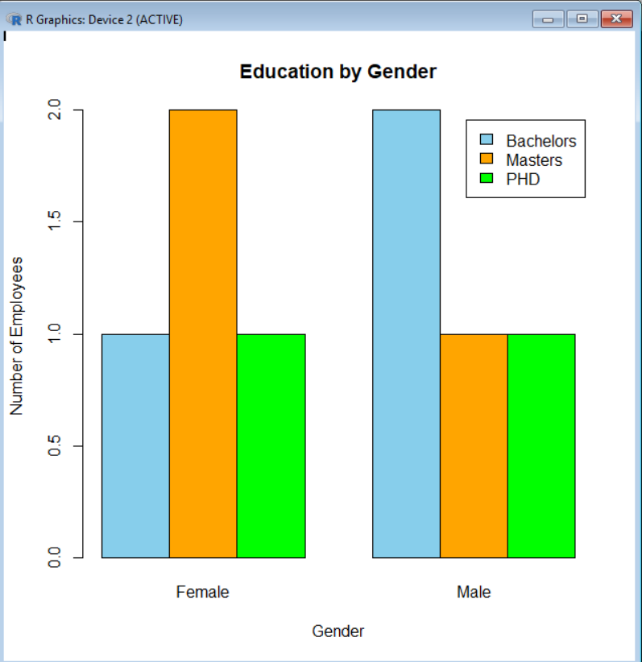

15. Stacked Bar Chart
employee <- data.frame(
Education = c("Bachelors","Bachelors","Masters","Masters",
"PHD","PHD","Bachelors","Masters",
"PHD","Bachelors"),
Gender = c("Male","Female","Male","Female",
"Male","Female","Male","Female",
"Male","Female")
)
stack <- table(employee$Gender, employee$Education)
barplot(stack,
col = c("skyblue","orange","green"),
legend.text = rownames(stack),
main = "Stacked Bar Chart of Employees",
xlab = "Education",
ylab = "Number of Employees")
